Content Beyond Syllabus-DBMS Lab

Aim: To design and implement a Mini-Project using Database (Bank Management System).

Theory:
Introduction
A Bank Management System is a software application designed to manage banking operations such as account creation, deposits, withdrawals, and transaction history. This project implements a desktop-based banking application with a graphical user interface and database connectivity to demonstrate practical implementation of DBMS concepts.
Objectives:
- Implement user registration and authentication system
- Perform deposit and withdrawal operations with balance validation
- Maintain transaction history in database
- Generate PDF reports of account statements
- Create an intuitive user interface for banking operations
Flow:
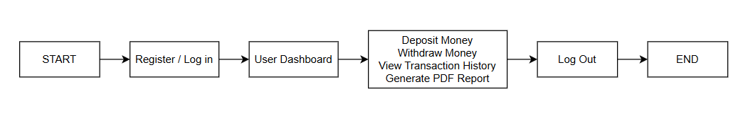

Technologies and Libraries Used:
- Python: Python serves as the core programming language for the application due to its simplicity and extensive library support. It handles the application logic, user input validation, and database interaction.
- Tkinter: Tkinter is Python’s standard GUI library and is used to build the entire user interface. It provides widgets such as buttons, labels, frames, and text boxes to design registration forms, login windows, and banking dashboards.
- SQLite: SQLite is a serverless, self-contained SQL database engine, embedded directly into the application. The database stores user details and transaction records. Using SQL queries, the application can perform operations like insertion, retrieval, and updates efficiently.
- ReportLab: The ReportLab library is used for generating PDF reports of transaction histories. This allows users to export and save their bank statements in a structured and professional format.
Database Design:
The system uses a relational database with two tables:
Users Table:
- account_number (Primary Key, Auto-increment)
- full_name, email (Unique), phone, password
- balance (stores current account balance)
- created_at (timestamp of account creation)
Transactions Table:
- transaction_id (Primary Key, Auto-increment)
- account_number (Foreign Key referencing Users table)
- transaction_type (Deposit/Withdrawal)
- amount, balance_after
- transaction_date (timestamp)
System Features:
- User Registration: Allows new users to create accounts by providing personal details and initial deposit. System automatically assigns unique account numbers.
- User Authentication: Validates email and password credentials against database records before granting access.
- Deposit Money: Users can add funds to their account. The system validates input, updates balance, and records the transaction.
- Withdraw Money: Enables cash withdrawal with balance validation to prevent overdraft. Checks if sufficient funds are available before processing.
- Transaction History: Displays all transactions in tabular format with details including type, amount, balance after transaction, and timestamp.
- PDF Export: Generates downloadable PDF statements containing complete transaction history with account details.
Working Methodology:
- Initialization: Application connects to SQLite database and creates tables if they don't exist
- Authentication: User logs in with email and password; credentials verified against database
- Dashboard: Upon successful login, user sees main interface with current balance and action buttons
- Transactions: User selects deposit/withdraw, enters amount, system validates and updates database
- History View: User can view all past transactions and export to PDF
- Data Persistence: All data remains stored in database file even after application closure

Output:
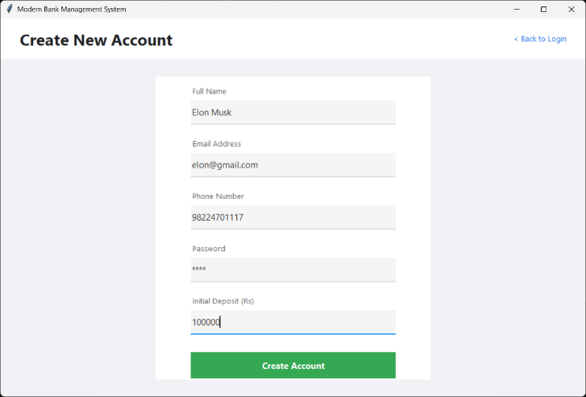 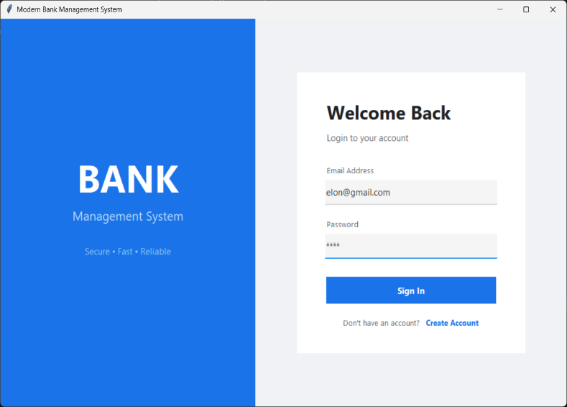
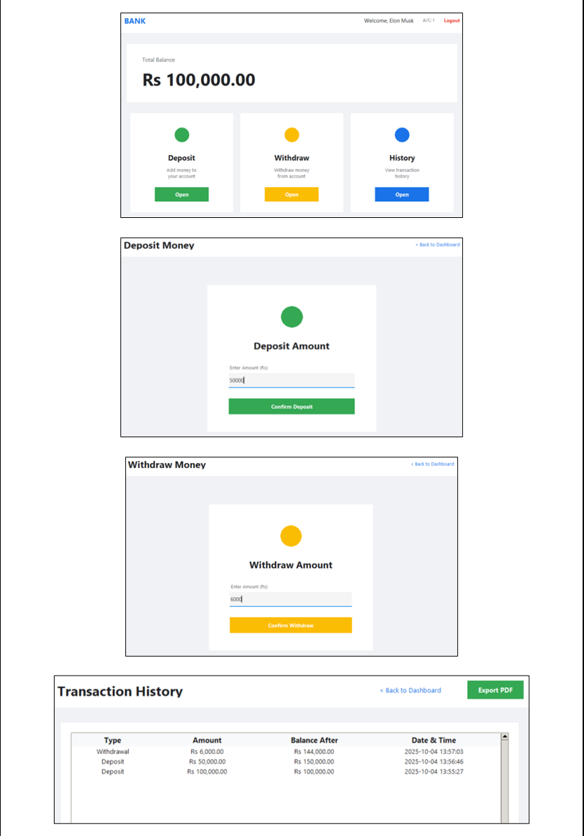

Conclusion:
Hence, we have successfully designed and implemented a mini-project using a database (Bank Management System).

